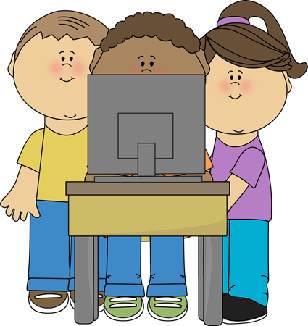
Good Digital Citizenship Laptop Pledge

I agree to be a good Digital Citizen and will follow the rules below to protect myself, my friends and our equipment. I will….

- take good care of our school’s laptops. I will:
- carry it with both hands
- type gently
- keep it clean and away from food and liquids
- not mark the screen with any objects (pencils, markers, crayons, etc.)
- never eat or drink while using equipment
- place it in my lap or on a desk or table at all times (never on the floor unattended)
- follow classroom procedures for using, taking out, shutting down and putting laptops away
- use only websites and kid-safe search engines allowed by my teacher
- not make changes to any settings or icons
- not download any programs
- report all inappropriate or sensitive material immediately and quietly to my teacher
- not show inappropriate photos or information to other students
- keep my personal information private (last name, address, password, lunch number etc.)
- report any bullying or inappropriate behavior to an adult
- not sign on or make comments as another student
Student Signature: ____________________________________ Date: _________
Parents, please sign below to indicate that you:
- have read and discussed this pledge with your child
- understand it is a privilege for students to use this technology
- agree that your child will follow these rules
- understand you may be financially responsible for the repair or replacement of stolen or abused equipment

Parent Signature: ____________________________________ Date: __________

