Teacher iPad Guidelines
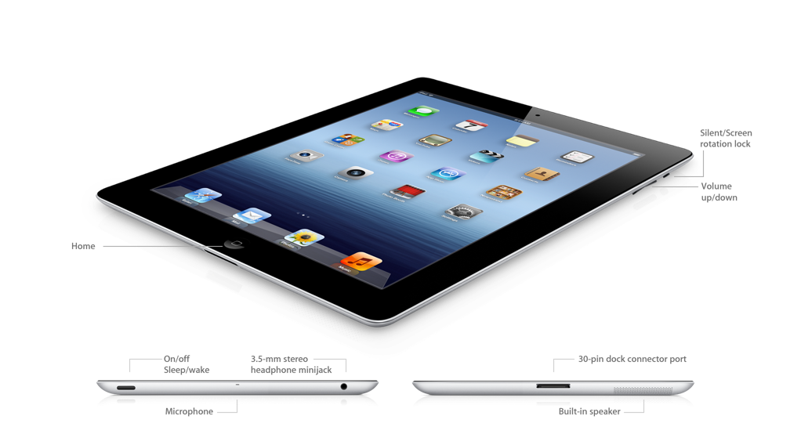
Before you get started…
- Assign an iPad number to each student.
- Make sure the students use the same iPad each time so they feel responsible for its care.
- Go over the iPad Good Citizen Pledge with your students and send home for signatures.
While using the iPads…
- If you need to plug the cart in (when power is less than 50%), make sure the cart’s power switch on the back is in the OFF position first. Plug the cart in and then turn the switch on. Make sure the power cable is not in the students’ way.
- The cart’s lock combination is ____. Push the lock handle in and then pull it out to release it and open the lock. (Do not share this number with students! Make sure you spin the combination numbers after opening the lock so students do not see the correct combination.) Keep the open lock on top of the cart.
- To unplug the iPads, pull on the charging connector, not the charging cable.
- Turn the cart’s power switch to OFF before you unplug the cart!
- Remind the students to carry the iPads with two hands and handle the iPads carefully.
- Do not leave the iPads or cart unattended in your classroom. If you leave your classroom (for lunch, specials, etc.), lock the iPads in the cart or lock your classroom door!
- Remind students they are NOT to change settings or delete or install apps.
- Monitor student use so they are using only the apps you have assigned.
When you are done…
- Make sure students return to the Home screen and close open apps.
- Return each iPad to its correct numbered slot (to ensure proper syncing and updating) and plug in the charging cable while pushing the iPad to the back of the cart.
- Lock the cart at the end of the day.

