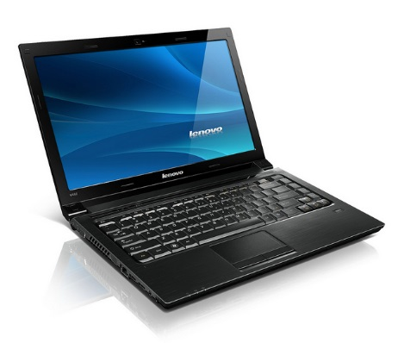Student Laptop Guidelines

Before you get started…
- Put a number on each laptop, and assign each laptop to one (or two) specific students. This will provide accountability for any damage, or inappropriate website use.
- Assign Technology helpers to oversee taking out and putting away laptops. Technology helpers should scan laptop keyboards and check for damage each time the laptop is put away. Teachers, remember that you should still carefully oversee your classroom laptops and monitor for damage even though you have student helpers.
- Go over the Laptop Good Citizen Student Pledge (found on the Media Website) with your students and send home for signatures. Use the Spanish language version if applicable.
- Sign up with Mrs. Falcone to teach your class correct use of the laptops if you wish.
While using the Laptops…
- Each laptop should have an assigned place in a cart.
- Do not remove the power cords from the cart. Please encourage technology helpers to keep the cords neat. Laptops should be charged in the cart only, as long as they have a working battery life.
- Teachers should constantly monitor student screens to make sure no inappropriate use is taking place. Teach your students to report an inappropriate website immediately. Students should not be allowed to wander aimlessly on the Internet.
- Remind the students to carry one laptop at a time, with two hands, never by the screen, and no food or liquids should be allowed nearby.
- Do not leave the laptops unattended in your classroom. If you leave your classroom (for lunch, specials, etc.), lock the laptops in the cart, or lock your classroom door.
- Remind students they are NOT to change settings or install any extensions or software.

When you are done…
- Make sure students shut down, and not merely log off the laptops.
- Students should never shut down the computer by pushing the on/off button. Teach them to shut down by going to the “start” menu.
- Return each iPad to its correct numbered slot and plug in the charging cable
- Lock the cart at the end of the day.

